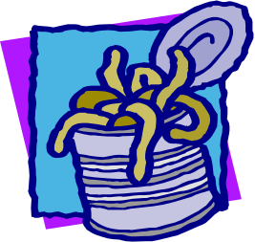
Darwin’s Natural Selection Worksheet Name ___________________________________

Read the following situations below and identify the 5 points of Darwin’s natural selection.

1) There are 2 types of worms: worms that eat at night (nocturnal) and worms that eat during the day (diurnal). The birds eat during the day and seem to be eating ONLY the diurnal worms. The nocturnal worms are in their burrows during this time. Each spring when the worms reproduce, they have about 500 babies but only 100 of these 500 ever become old enough to reproduce.

a. What worm has natural selection selected AGAINST? _________________ FOR? ________________

Darwin's 5 points: Identify the 5 points in the scenario above.
Population has variations. _________________________________________________________________
Some variations are favorable. _____________________________________________________________
More offspring are produced than survive._________________________________________________
Those that survive have favorable traits. ____________________________________________________
A population will change over time. ________________________________________________________

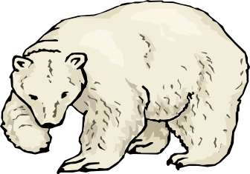
2) There are 3 types of polar bears: ones with thick coats, ones with thin
coats and ones with medium coats. It is fall, soon to be winter. The
temperatures are dropping rapidly and the bears must be kept warm,
or they will freeze to death. Many of the bears have had ~2 cubs each
but due to the extreme temperatures, many mothers only have one
cub left.

a. What bear will natural selection select AGAINST? ___________________ FOR? _________________

Darwin's 5 points: Identify the 5 points in the scenario above.
Population has variations. _________________________________________________________________
Some variations are favorable. _____________________________________________________________
More offspring are produced than survive._________________________________________________
Those that survive have favorable traits. ____________________________________________________
A population will change over time. ________________________________________________________

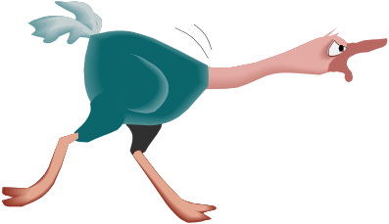
3) In ostriches, there are 2 types: ones that run fast and those that run slowly. The fast birds can reach up to 40 miles an hour. Jackals love to eat ostrich, and they can reach speeds of up to 35-40 miles per hour. A flock of ostrich will lay ~ 10 eggs (each mother only lays 1), but many rodents break into the eggs and eat the fetus before they hatch.
a. What ostrich will natural selection select AGAINST? __________________ FOR? ________________

Darwin's 5 points: Identify the 5 points in the scenario above.
Population has variations. _________________________________________________________________
Some variations are favorable. _____________________________________________________________
More offspring are produced than survive._________________________________________________
Those that survive have favorable traits. ____________________________________________________
A population will change over time. ________________________________________________________

4) There are two types of rabbits: those that strictly eat grass and those
that strictly eat berries and flowers. A drought occurs one year, and the
plants have difficulty producing any extras (flowers, berries, etc.).
They can only try and keep themselves green. The rabbits have
had babies all year long but many are eaten by foxes or hawks
Due to the drought, many have starved to death.

a. What rabbit will natural selection select AGAINST? __________________ FOR? _________________

Darwin's 5 points: Identify the 5 points in the scenario above.
Population has variations. _________________________________________________________________
Some variations are favorable. _____________________________________________________________
More offspring are produced than survive._________________________________________________
Those that survive have favorable traits. ____________________________________________________
A population will change over time. ________________________________________________________

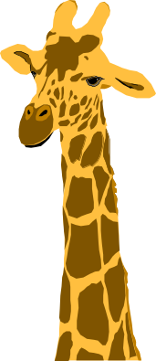
5) Bob believes that giraffes have long necks because they have stretched their necks to try and reach food that is high in trees. Since the parent had stretched its neck, it passed the long neck on to its offspring.

Ryan believes that giraffes have long necks because the ones with long necks were able to reach the food, and those with short necks could not and died. The long necked giraffes reproduced, and soon all of the giraffes had long necks.

a. Who thinks like Lamarck? __________________________________________________

b. Who thinks like Darwin? ___________________________________________________

c. Who disproved the idea of inheritance of acquired traits using tailless mice? ________________

